Git Merge Conflict

When two branches are trying to merge, and both are edited at the same time and in the same file, Git won't be able to identify which version is to take for changes. Such a situation is called merge conflict. If such a situation occurs, it stops just before the merge commit so that you can resolve the conflicts manually.

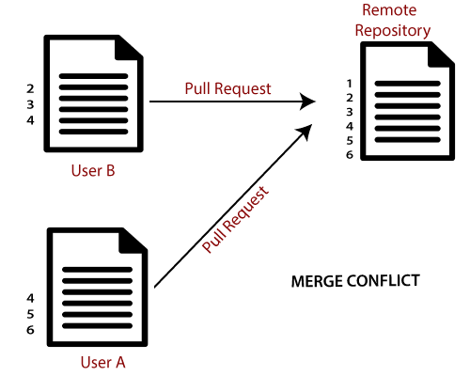

Let's understand it by an example.

Suppose my remote repository has cloned by two of my team member **user1** and **user2**. The user1 made changes as below in my projects index file.

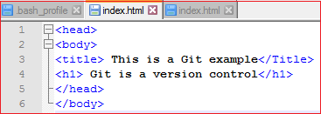

Update it in the local repository with the help of git add command.

Git Merge and Merge Conflict

Now commit the changes and update it with the remote repository. See the below output:

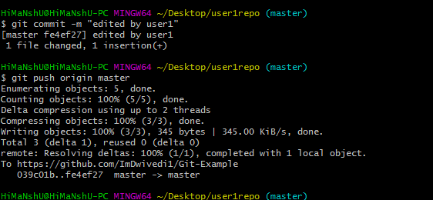

Now, my remote repository will look like this:

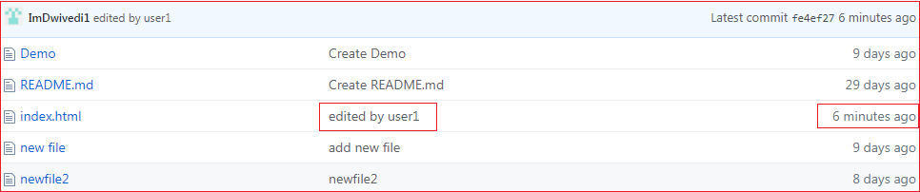

It will show the status of the file like edited by whom and when.

Now, at the same time, **user2** also update the index file as follows.

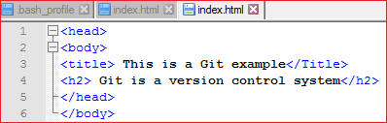

User2 has added and committed the changes in the local repository. But when he tries to push it to remote server, it will throw errors. See the below output:

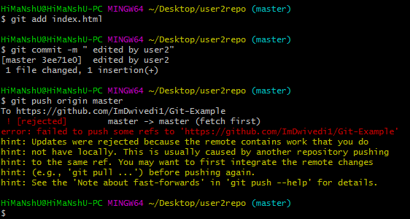

In the above output, the server knows that the file is already updated and not merged with other branches. So, the push request was rejected by the remote server. It will throw an error message like **[rejected] failed to push some refs to <remote URL>**. It will suggest you to pull the repository first before the push. See the below command:

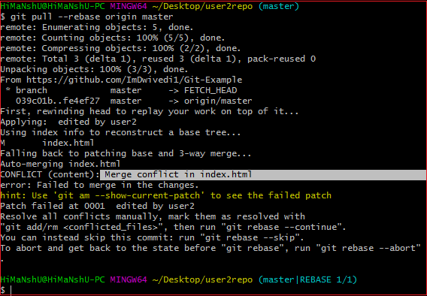

In the given output, git rebase command is used to pull the repository from the remote URL. Here, it will show the error message like **merge conflict in <filename>**.

Resolve Conflict:

To resolve the conflict, it is necessary to know whether the conflict occurs and why it occurs. Git merge tool command is used to resolve the conflict. The merge command is used as follows:

1. $ git mergetool

In my repository, it will result in:

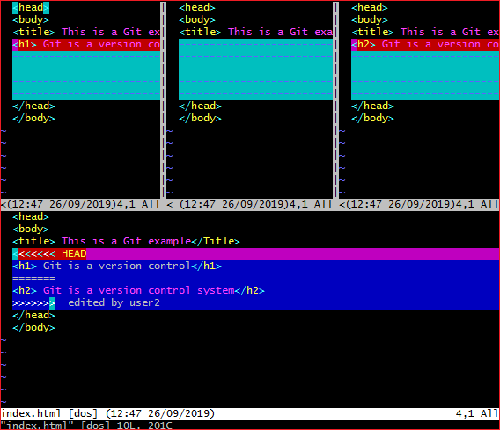

The above output shows the status of the conflicted file. To resolve the conflict, enter in the insert mode by merely pressing **I key** and make changes as you want. Press the **Esc key**, to come out from insert mode. Type the: **w!** at the bottom of the editor to save and exit the changes. To accept the changes, use the rebase command. It will be used as follows:

1. $ git rebase --continue

Hence, the conflict has resolved. See the below output:

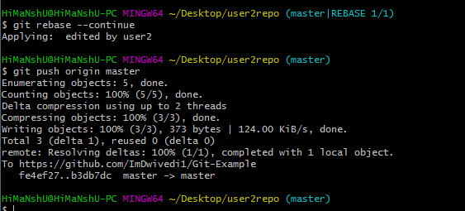

In the above output, the conflict has resolved, and the local repository is synchronized with a remote repository.

To see that which is the first edited text of the merge conflict in your file, search the file attached with conflict marker **<<<<<<<**. You can see the changes from the **HEAD** or base branch after the line **<<<<<<< HEAD** in your text editor. Next, you can see the divider like **=======**. It divides your changes from the changes in the other branch, **followed by >>>>>>> BRANCH-NAME**. In the above example, user1 wrote "<h1> Git is a version control</h1>" in the base or HEAD branch and user2 wrote "<h2> Git is a version control</h2>".

Decide whether you want to keep only your branch's changes or the other branch's changes, or create a new change. Delete the conflict markers **<<<<<<<, =======, >>>>>>>** and create final changes you want to merge.